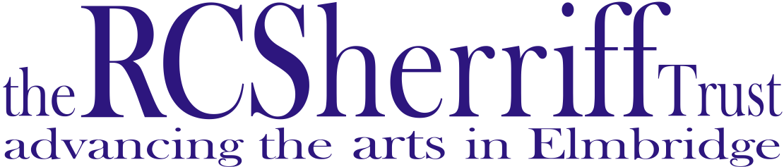

ANNUAL REVIEW
2015
&
PROPOSED PROGRAMME 2016
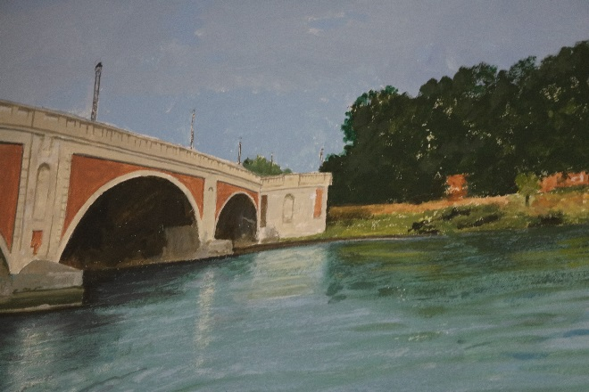
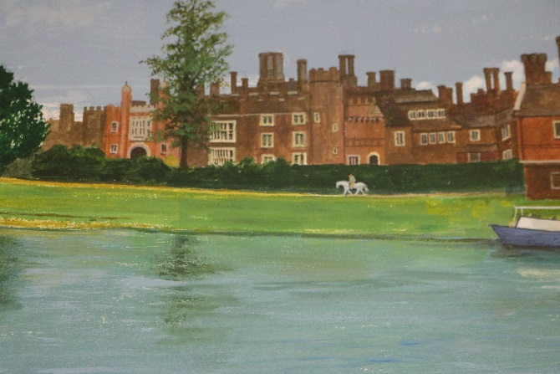

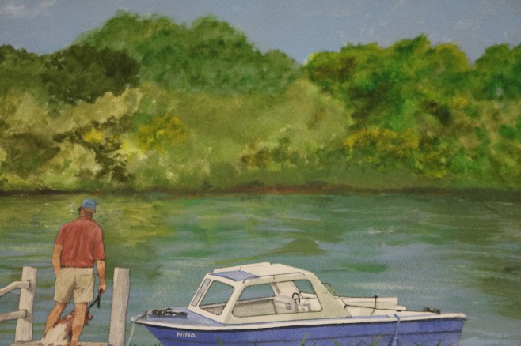
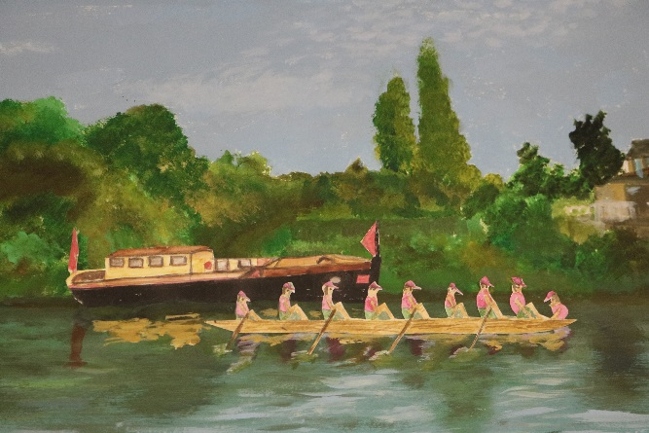

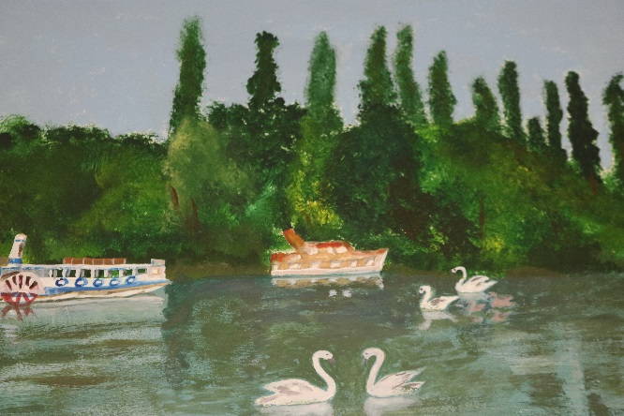
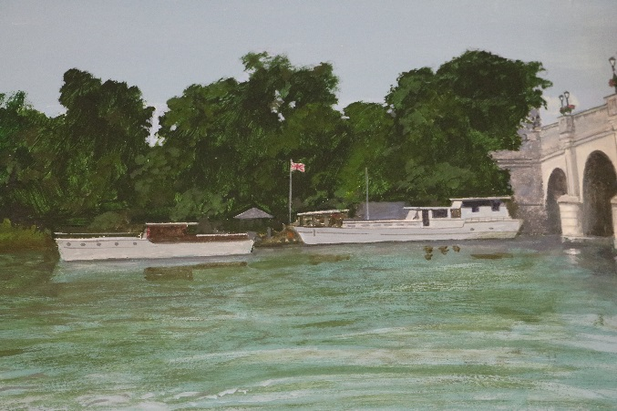

CONTENTS

- AIMS OF THE R C SHERRIFF TRUST 1
- OBJECTIVES 2
- PROGRAMME FOR 2015: OUTCOMES *
- Governance, Networking, Planning
& Strategy *
- General Management & Marketing *
- Arts Project *
- Grants *
- PROGRAMME FOR 2016 *
- Directly Managed Arts Projects *
- Partnership Initiatives *
- General Management, Marketing & Network *
- TRUSTEES *
- STAFFING *
- NEW DIRECTOR *

APPENDICES:
- List of Grants Awarded
- Summary of Grants by Type
- Summary of Grants by Art Form
- Summary of Grants by Area

THE AIMS OF THE R C SHERRIFF TRUST
To develop, promote and support community and professional arts in the Borough of Elmbridge, through:
- Awarding grant aid to local artists, arts organisations, venues and projects.
- Organising and directly managing arts initiatives.
- Publishing and distributing a free listings magazine, “Arts Focus”, three times a year.
- Offering advice and information to the arts community and to members of the public.

Mount Felix Tapestry

OBJECTIVES
The R C Sherriff Trust supports the arts in Elmbridge, through its grant-giving and its self-generated projects, for the following purposes:
- To support and stimulate excellence, new ideas and innovation in the arts in the Borough, whether amateur, community or professional.
- To invest in the creative talent of individual artists in Elmbridge and to provide opportunities for them to further develop their skills and knowledge.
- To increase opportunities for all Elmbridge residents to take part in or experience high-quality arts activities, regardless of economic or social circumstances.
- To increase, develop and improve resources and facilities for the arts in the Borough
- To support and encourage initiatives aimed at the development of new audiences and venues for the arts in the Borough
- To promote good practice in management, marketing, fundraising and educational work amongst arts organisations in Elmbridge, and to encourage collaboration.

PROGRAMME FOR 2015: OUTCOMES

Governance, Networking, Planning and Strategy:
- Convened 4 meetings of the full Board (quarterly).
- Continued the working relationships with Surrey Arts Officers and participated in some meetings of the Surrey Arts and Leisure Development Officers Group (SALDO).
- Met regularly with the Elmbridge Arts Development Officer to co-ordinate plans and services and to agree on areas of co-operation, such as the 2015 Literary Competition & Festival and the Proms in the Park at Churchfields Recreation Ground as part EBC’s The Leisure Live Event.
- Maintained and increased working relationships with other partners in the Borough, including The International Youth Arts Festival; Brooklands Museum; Carer Support Elmbridge; the Centres for the Retired; Elmbridge Arts Forum; Elmbridge Arts Council; Elmbridge Borough Council; Elmbridge Community Link; Elmbridge Museum; Elmbridge Youth Theatre; Hinchley Wood Education Trust; individual schools; JTI; Love of Learning; Music in Hospitals and the Princess Alice Hospice; Paragon Community Housing Group; Riverhouse Barn Arts Centre; Walton Business Group; Walton Charity; and Walton and Weybridge Advocacy Group.

General Management and Marketing:
- Administered and supervised 4 (quarterly) grant application/assessment ‘rounds’.
- Produced and distributed 3 issues of “Arts Focus”, with a regular review of, and improvements to, the format, database, and distribution system, through the services of a freelance editor.
- Continued to improve the services and information available via the website, through the services of a freelance Webmaster.
- Continued to promote and manage the hire of our two sets of Radio Microphones (Trantec and Sennheiser systems) and Exhibition Stands. We have 16 microphones available, various combinations of which were hired out on 11 occasions.
- Continued to review and improve the office administrative systems, and to keep the Trust’s administration costs under close scrutiny.

Arts Projects:

Due to the planned retirement of Loretta Howells as Director at the end of 2015, the number of projects that the Trust was involved with was curtailed in anticipation of the plans of the new Director. The process of finding a successor for the position of Director started in September 2016 with the successful applicant, Peter Allen, appointed in November 2015.

2015 Directly Managed Projects
3.3.1.1 Elders Arts Project (a three-year programme from June 2011)

The Elders Arts Project received a further three years funding from JTI in 2014 which allowed it to continue to run in partnership with Carer Support Elmbridge, Paragon Community Housing Group and Walton Charities.

The weekly Singalong Session continued in January at Fenner and Sherwood Houses running throughout the year with three breaks over Easter, the summer and Christmas. Separate from the project, the Fenner group (which had about 30 regular members) was invited to open a concert to raise money for SPARKS, the Mayor’s charity on 29 October at Danes Hill School, performing not only for the Mayor of Elmbridge but for dignitaries from surrounding Boroughs also.

The Singalong Singers, as they have become known, also participated at EBC’s “Leisure Live – Storm the Stage” event on Saturday 4 July, on the outdoor stage at Churchfields Recreation Ground, Weybridge celebrating American Independence Day with a selection of songs from the Great American Songbook.

Leisure Live 2015
The monthly Art Workshops continued at City Wharf House, led by the artists, Jenny Cave-Jones and Sue Meers with occasional help from Mary Quinn with the members able to work at a pace and on a topic which suited them, with a variety of materials to choose from. When Jenny left to have her baby the workshops were taken over permanently by Sue Meers. JTI continued to provide volunteer helpers on an occasional basis.

Art work by Pam Francis, Elders Project 2015

The Workshops offered a great opportunity for participants to explore their skills, using several different art forms. As well as general art work the group started work on panels that will go to making up the Mount Felix Tapestry that is being managed by Riverhouse and have created the River Mural which is quite breath taking in its composition. We are looking at how this piece might be seen by the wider community by taking it ‘on tour’.

Over the twelve months, Sam Thompson has continued to organise regular group outings to performances and concerts by local companies, in addition to the regular activities. This support for organisations such as Walton and Weybridge Amateur Operatic Society and Elmbridge Youth Theatre offers the participants of the Elders Project the opportunity to see performances and hear work they might not ordinarily have been accessible to them.

These additional activities not only tackle and address the larger issues of isolation and physical and mental well-being amongst members of the Elders Arts Project, but also increase the audiences for Elmbridge arts events and has supported organisations such as Walton and Weybridge Amateur Operatic Society and Elmbridge Youth Theatre. The participants pay for their own tickets, but transport is provided free by Paragon and when available, by Walton Charity. The project continues to fulfil its aim of breaking down social isolation among the elderly while offering them the opportunity to engage with the arts.

11th Annual Literary Festival & Competition: “Flights of Fantasy”

To celebrate the anniversaries of some of the most famous works of literary fantasy: the 150th anniversary of “Alice’s Adventures in Wonderland”, the 60th of “The Lord of the Rings” and the 20th of “the Northern Lights”, the 2015 Literary Festival and Competition took ‘fantasy’ as its theme.

A weekend Festival of talks and workshops was planned for 14-16 August which was a partial success. The talk, ‘Mr Dodgson in Wonderland: Alice and the Man Who Invented Lewis Carroll’ by renowned author Brian Sibley on Lewis Carroll, run in conjunction with EBC’s Royston Pike Lecture Series was very successful. As were the workshops run by Jonathan Barnes on Exploring & Crafting the Fantastic. Sadly participation in the festival by younger people was less successful and a talk by the author Caroline Green and workshop by author Patricia Elliot had to be cancelled.

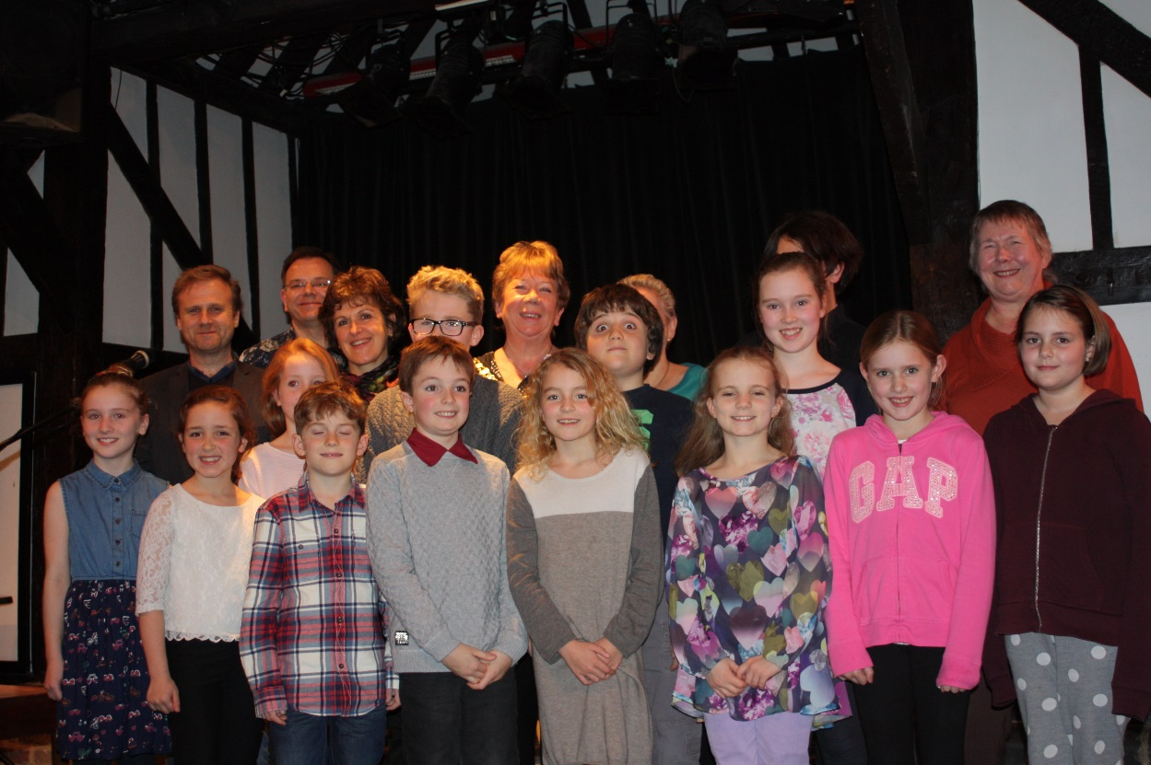
2015 Literary Competition Winners and Commended Finalists 8 to 11 Age Group

The competition was, however, once more, very successful with a total of 147 entries. The prize giving and public readings for the winning and highly commended entries were held at Riverhouse on Saturday 28 November. The afternoon session was for the 5–13 age-group, when the prizes were presented by The Mayor of Elmbridge, Councillor Jan Fuller. Councillor Tannia Shipley, Chair of The R C Sherriff Trust, distributed the prizes to the 14 + categories at the evening session. Once again, the standard of writing and of imagination was very high and we were delighted that, in addition to the independent entries, a number of schools took part in the competition this year, several entering pupils in more than one age category: Cardinal Newman Catholic Primary, Claygate Primary, Cranmere Primary, Heathside, and St Charles Borromeo Catholic Primary and ACS Cobham. All the winning stories and poems are now available to read on our website.

      - R C Sherriff Young Musician of the Year

In 2014 the Trust received a bequest from the estate of Nigel Truefitt of £25,000. As Nigel had a passion for classical music it was decided by the Trustees that a way of using this legacy would be the creation of a ‘Young Musician of the Year Award’.

The aim was to have four sections: Brass, Piano, Strings and Woodwind. With closing date for entries on Tuesday 1 September and entrants informed of the outcome by the end of September. Live section heats would then take place in the evenings of Tuesday – Friday 17th–20th November, with the final on Saturday 21st, at Riverhouse Barn Arts Centre. The competition was open to musicians aged 18 or under on 16th November 2015; who lived in the borough of Elmbridge; and who have reached ABRSM Grade 8 standard, or the equivalent, on their chosen instrument(s).

Unfortunately, even with the closing date pushed back to October and a concerted school push we were unable to run the competition as planned.

However, the Showcase Evening which was organised to replace the competition element was very successful with five superb performances making up a delightful evening. The Performers were:

Catherine Porte – Cello
Mendelssohn – Cello Sonata No 2 in D major,
Op 58: Movements iii) Adagio and iv) Molto Allegro e Vivace

Eniola Akin-Olugmemi - Piano
Piano - Claude Debussy – Arabesque No.1 for Piano
Cello - J.S. Bach - First Solo Cello Suite in C major

Alasdair Wilson - Cello - JS Bach - Courante from the First Solo Cello Suite
Piano - Prokofiev - Visions Fugitives – Nos 18 and 14

Jason Bae – Violin
Wolfgang Amadeus Mozart – Violin Concerto No. 3 K.216 in G Major – First Movement
Fritz Kreisler – Prelude and Allegro in style of Pugnani

Harry Son - Piano
Ludwig van Beethoven – Piano Sonata Op.31 No.2 (Tempest – Final Movement)
Frederic Chopin – Fantasie Impromptu Op. 66
Jon Schmidt – All of Me

Other Initiatives Financially Supported by the Trust through Partner Organisations
      - Elmbridge Hundred

Discussions were held with Elmbridge Borough Council with regards to the Elmbridge Museum website hosting the Elmbridge 100 website. However with the leaving of the Museum Manager at the end of 2015 there is still a question with regards to the future of the website and this cannot fully be resolved until a new manager is in post.

It is still felt that whatever money remains in the project fund should be used to complete the unfinished biographies.

      - Frost Festival

The Festival of Light had its 10th procession in 2015 and sadly, there were several reasons why the organisers agreed to sit down and rethink. The original idea, seeded by the late Sarah Jane Shellard, artist Donagh Curwen and Sam and Loretta had simply grown too big! This year, Riverhouse adopted the creative torch and decided to bring the procession back to the community. While The Frost Festival was smaller, it was a great success due to the huge team of creative enthusiastic and dedicated people behind it. The Trust helped both financially and administratively with health and safety and organisation matters.

      - Proms in the Park

As part of Elmbridge Borough Council’s Leisure Live The Trust worked with the Arts Development Officer on Proms in the Park which was held on the evening of 3 July at Churchfields Recreation Ground, Weybridge. The evening of performances showcasing the talents of young singers and musicians in Elmbridge culminated with a performance by The Hinchley Wood Brass Band who had been working with Majestic Brass. This joint venture and the final performance by Majestic Brass was funded by The Trust.

      - Other Arts Projects and Organisations

The Trust continued to award grant funding and support to arts organisations, individuals and community groups in order for them to provide a programme of arts activities targeted at particular ‘client’ groups across the borough. Organisations in receipt regular funding are Riverhouse Arts Centre, Elmbridge Arts Council, Elmbridge Community Link, Elmbridge Youth Theatre, Music in Hospitals and The Vera Fletcher Hall.

The Director continued as a Trustee (on a personal basis) of Hinchley Wood Education Trust.

Grants:
35 grants were awarded during the year, through a combination of Arts Initiative Projects delivered by partner organisations, Regularly Funded Organisations, Three year Funding, and the four Open Application deadlines, dispensing a total of £61,626.38. The “Actual” total dispensed will be less, as not all the Underwriting Grants will have been taken up in full.
A list of grants awarded is attached (Appendix I). Grants are further summarised by type (Appendix II), by art form (Appendix III), and by the ‘geographic spread’ of this expenditure, throughout the borough (Appendix IV).

PROGRAMME FOR 2016:

Directly Managed Arts Projects:

The Elders Arts Project
The final year of the 3 Year Funding from JTI will be awarded in June and an application for another 3 Year Funding will be made.
A third project ‘Words & Pictures’ combining the Singalong and Art groups and other older people’s groups and daycentres will be started in April with the aim of increasing the numbers of participants.
We will continue to organise group outings to appropriate arts events in the borough.

The Mount Felix Tapestry Community Stitch Project
This will continue to be a partnership project with Riverhouse Arts Centre (the project leaders) and EBC.

Proms in the Park
Churchfield Recreation Ground, Weybridge,
Friday 24 June 2016

Elmbridge Youth Arts Festival
Inc. Elmbridge @ The Rose

The Twelfth Annual Elmbridge Literary Competition
(In partnership with EBC), on the theme of “Love”, to commemorate the 400th Anniversary of the death of William Shakespeare.
Inc. Foolish Mortals, an evening of theatre and song on the theme of Love

WWI Commemoration Project 2017 ‘Toward the Sun’

Young Musician of the Year

St James’ Artist in Resident

Other Initiatives - To Be Achieved Through Partner Organisations
Continued financial support to the Regularly Funded Organisations, arts venues, and Arts Initiative Projects grant-aided in 2014.
4.3 General Management, Marketing and Networking:
- Organising and convening 4 (quarterly) Board meetings
- Administration of 4 (quarterly) grant application deadlines/assessments
- Production of 3 editions of “Arts Focus”
- Continued improvement of the design, usefulness and accessibility of the Trust’s website
- Continued development of the Recommended Artists Database, and promotion of this service to schools, youth centres and community groups
- Continued promotion and hiring out of the Radio Microphones and Exhibition Display panels
- Continued membership of the Hinchley Wood Education Trust
- Continued expansion of our network of Elmbridge and Surrey contacts/organisations.

TRUSTEES
The following served as Board Members and Trustees in the course of the year:
Cllr Barry Cheyne
Cllr Nigel Cooper (Vice-Chairman)
Cllr Mrs Shweta Kapadia
Cllr Mrs Ruth Lyon
Mr Brian Nathan
Mr Frank Renton
Cllr Mrs Tannia Shipley (Chairman)
Ms Wendy Smithers
Cllr James Vickers
Co-opted members:
Cllr Mrs Elizabeth Cooper
Mr David Walsh (Asset Management Consultant)
It is with great sadness while this report was being compiled David Walsh passed away.

STAFFING

Permanent:
Loretta Howells: Director (full-time)
Sandra (Sam) Thompson: Administrator/Project Manager (full-time)
Dean Blanchard: Treasurer (part-time), assisted by Benjamin Hanger, both of whom are employees of Elmbridge Borough Council (Finance Department).
Freelance:
Totum Printers printed the three issues of Arts Focus during the year.
Tim Kerr, a sound engineer, continued to maintain, and advise on, the Trust’s radio microphones, as a volunteer.
David Thompson acted as webmaster and Editor of Arts Focus.
David Walsh: Asset Management Consultant, retained his responsibility for overseeing the Trust’s investment portfolio and liaising with Louise Hall (Investec), the Trust’s Fund Managers.
Investec continued as the Trust’s Investment Managers. Barclays was retained as the Trust’s Bank.

New Director
Following the retirement of Loretta Howells at the end of 2015, The Trust was pleased to announce the appointment of Pete Allen as its new Director.
Prior to his appointment Pete had been employed by Elmbridge Borough Council as their Arts Development Officer working closely with The R C Sherriff Trust on a number of projects including the annual Elmbridge Literary Competition, Proms in the Park and WW1 Commemoration Projects.
Before joining Elmbridge Borough Council, Pete was co-founder and artistic director of WhirlygigArts which ran CRYPT (Cranleigh Young People’s Theatre), CMYT (Chequer Mead Youth Theatre) and The Big Picture Young People’s Film Workshop. He co-founded Storm the Stage Young People’s Theatre for Mole Valley District Council and was the Director of The Together in Waddon Community Project. He has also worked extensively as a professional theatre director and film-maker.
Pete takes over as Director of The RC Sherriff Trust, replacing Loretta Howells who is stepping down after 12 years in the role. During her time as Director, Loretta oversaw the development of The R C Sherriff Trust into the main supporter of the arts in Elmbridge offering grant awards to hundreds of community groups, arts organisations, educational establishments and professional artists as well as developing projects like The Literary Competition, The Elmbridge Young Musician of The Year and Arts Focus.
Pete Allen
Director
March 2016

APPENDIX 1: GRANTS AWARDED 2015
GRANT NO. | NAME |  | PURPOSE |  | AWARDED
3-YEAR FUNDING
009/15 | Riverhouse Barn | Trustees agreed to renew the 3 year funding agreement with Riverhouse Barn Arts Centre Ltd. For 2014/15/16. Paid monthly. |  |  | £12,000.00
 | Total |  |  | 1 Grant | £12,000.00
ARTS INITIATIVE PROJECTS (AIP)

006/15 | Esher and Dittons Youth Orchestra | A contribution to the costs of a further set of three five-week courses (each culminating in a public performance) between September 2015 and May 2016. |  |  | £1,500.00
007/15 | Love of Learning | To support Love of Learning run a programme of arts-based activities for disadvantaged and vulnerable groups in the Elmbridge Community. |  |  | £2,500.00
008/15 | Walton and Weybridge Advocacy Group | To run a programme of visual arts and craft workshops at Riverhouse, culminating in an exhibition, for members of the Walton and Weybridge Advocacy Group. |  |  | £3,500.00
017/15 | Enigma Theatre | Trustees agreed to allocate the sum of £1,500 to Enigma Theatre from our Arts Initiatives budget for 2015 as a contribution to the cost of staging one major production at Riverhouse in the autumn. |  |  | £1,500.00
018/15 | Walton Charity | To support Walton Charity in partnership with Burview Hall, run a series of arts and crafts workshops, for adults with learning disabilities, in the Burview Hall woodlands in June/July 2015 led by artist, Imogen Andrews. The project culminated in a community / celebratory event. |  |  | £4,000.00
 | Total |  |  | 5 Grants | £13,000.00
CAPITAL PROJECTS

028/15 | The Cobham Band | A contribution towards the costs of purchasing two new cornets, as part of their commitment to improving their stock of instruments and the quality of the sound the band produces. |  |  | £2,000.00
029/15 | The Whiteley Homes Trust | A contribution towards the costs of installing a new sound system in Whiteley Village Hall. The Hall is a popular and busy venue which is used by a large number of clubs and societies from within the Village, along with many groups from the wider community (eg Stagecoach, Weybridge Association of Decorative and Fine Arts, Desborough Players and the Ember Big Band), so that the resources of the Village are shared with the widest possible audience. |  |  | £2,000.00
038/15 | The Barn Theatre Club | A contribution towards the costs of purchasing and installing a new lighting rig in the Barn Theatre. |  |  | £2,500.00
 | Total |  |  | 3 Grants | £6,500.00
PROJECT GRANTS (Individuals)

022/15 | Agnes Meadows | A contribution towards the costs of putting on informal monthly workshops in writing and performing poetry, at Riverhouse, for a year, beginning in June 2015. These will be a mix of creative writing workshops, open surgery/Q&A sessions to explore/edit existing work, and Open Mic nights |  |  | £1,500.00
023/15 | Jessica Rinland | A contribution towards the costs of making a film about Black Pond. The film will explore the history of the landscape in the area of Esher and Arbrook Common, and the trees and flora found there. She has been working with the EBC Countryside Estates Officer, Dave Page, and Pete Allen, the Arts Development Officer; and she will also be collaborating with Dr Brian Spooner and Dick Adler, both local residents and retired Mycologists of Kew Gardens. |  |  | £2,000.00
036/15 | Andrew Brewis (Noted for Music) | An Underwriting Grant towards the cost of bringing critically-acclaimed professional musicians, “Gypsy Dreamers” to Elmbridge to give a concert at the Vera Fletcher Hall in February 2016, preceded by a free performance at a Centre for the Community and at a local school. |  |  | £500.00
 | Total |  |  | 3 Grants | £4,000.00
PROJECT GRANTS (Organisations)

011/15 | IID Consortium | A contribution to the costs of delivering 15 high-quality Creative Seated Dance sessions, by professional dance artists/teachers, over 8 months, to 5 groups of people suffering from dementia and/or Parkinson’s Disease, in Claygate, Molesey, Thames Ditton and Weybridge, beginning in February 2015. |  |  | £1,400.00
012/15 | Molesey Centre Social Committee | A contribution towards the costs of Echoes of Remembrance, a four year inter-generational project based around a fictional solder, poetry, drama, arts and crafts. |  |  | £1,300.00
013/15 | Monkey Theatre | A contribution to bringing professional dancer and choreographer, Lindsay Hibss, to work with Monkey Juniors (ages 7-11) on When the Bell Rings, a new piece of physical theatre, scripted by Adrian Preater to be performed at Riverhouse. |  |  | £1,200.00
014/15 | Promenade Choirs | A contribution towards the costs of bringing in a professional orchestra to accompany the choirs Spring Concert in March 2015. |  |  | £1,000.00
019/15 | All Saints Church, Weston Green | A contribution towards the costs of putting on a photographic exhibition and a gala film screening, in Spring 2016, to showcase the results of a Video and Photography Arts Project for the All Saints Weston and Lower Green Youth Groups, running from September 2015. |  |  | £950.00
020/15 | The Eikon Charity | A contribution towards the costs of running a storytelling workshop at Riverhouse in the autumn half-term for 15 vulnerable young people aged 12 -16. Targeting young people, particularly those from RES and the Walton Youth Centre, the workshop will boost the participants’ confidence and provide an experience they would not otherwise be able to access due to financial hardship. |  |  | £500.00
021/15 | St Mary with St Johns Church | A grant to enable the Church to provide arts, crafts and music activities for local residents at the annual “Big Lunch” at the Cromwell Centre, St John’s Estate, on Sunday 7th June. |  |  | £250.00
030/15 | Let them Help Themselves | A contribution to the costs of putting on free family workshops in African drumming and dance, on Saturday 31st October, at the Cecil Hepworth Playhouse, Walton, as a contribution to Black History Month in Elmbridge. |  |  | £500.00
032/15 | Walton Methodist Church | A contribution to the costs of the development and production phase of a community theatre project, to devise their own version of 'Cinderella', involving young people in every aspect of putting on a show. |  |  | £1,000.00
 | Total |  |  | 9 Grants | £8,100.00
REGULARLY FUNDED ORGANISATIONS (RFO)

001/15 | Elmbridge Arts Council | Trustees renewed their funding agreement with Elmbridge Arts Council for a further two years. |  |  | £600.00
002/15 | Elmbridge Community Link | A contribution towards their monthly music workshops and annual concert. |  |  | £2,500.00
003/15 | Elmbridge Youth Theatre | A contribution in the form of an underwriting grant towards EYT's major annual production in Spring 2014. |  |  | £1,450.38
004/15 | Music in Hospitals | A contribution towards a series of Concerts in care homes, hospitals and hospices around Elmbridge. |  |  | £3,000.00
005/15 | Vera Fletcher Hall | A grant to support, and help to develop further, the Hall's artistic programme; and to assist in improving their marketing strategy, in order to increase audiences and box office takings. |  |  | £5,000.00
 | Total |  |  | 5 Grants | £12,550.38
SCHOOLS FUND

010/15 | Ashley C of E Primary School | A contribution towards 4 Inset Workshops to be led by the Prince's School of Traditional Arts. |  |  | £2,000.00
 | Total |  |  | 1 Grant | £2,000.00
UNDERWRITING GRANTS

015/15 | Claygate Choral Society | An Underwriting Grant towards the cost of putting on a performance of Purcell's semi-operatic work, "King Arthur", |  |  | £500.00
016/15 | Oxshott & Cobham Music Society | An Underwriting Grant towards the cost of a concert by the Fibonacci Sequence at Holy Trinity Church, Claygate |  |  | £500.00
024/15 | A Capella Singers | A contribution towards the cost of their 50th Anniversary, “Golden” concert, including works by Handel, Pearsall and Purcell, with a 5-piece Baroque ensemble, using period instruments, and 4 professional soloist singers, on Saturday 27th June 2015, in St Mary’s Parish Church, Oatlands. |  |  | £500.00
025/15 | Celia Andrews | A contribution towards the costs of putting on “Rural Rumpus”, a revue of sketches and songs incorporating local references, at Riverhouse, on Thursday 21st May 2015. |  |  | £200.00
026/15 | Oxshott Choral Society | An Underwriting Grant towards the cost of their Summer Concert, “Torrents in Summer”, comprising words and light music celebrating the countryside and the British weather, at St John’s School Chapel, Leatherhead, on Saturday 13th June 2015. |  |  | £469.00
027/15 | Walton and Weybridge Amateur Operatic Society | An Underwriting Grant towards the cost of putting on their spring production of “The Hot Mikado”, at the Cecil Hepworth Playhouse, from Tuesday 12th – Saturday 16th May 2015. |  |  | £500.00
033/15 | Ember Choral Society | An underwriting grant towards the cost of the Society’s Autumn Concert, comprising Haydn’s “Nelson Mass” and Mozart’s “ C Minor Mass”, on Saturday 28th November 2015 at Holy Trinity Church, Claygate |  |  | £500.00
037/15 | Oxshott Choral Society | An underwriting grant towards the cost of their Christmas Concert, featuring Mozart’s “Solemn Vespers” plus Carols, at St Andrew’s Church, Oxshott, on Saturday 12th December 2015. |  |  | £307.00
 | Total | 8 Grants |  |  | £3,476.00
TOTAL GRANTS AWARDED |  | 35 Grants |  |  | £61,626.38

SUMMARY
Grants by Type 2015
 | % of Total Grants Awarded | No. of Grants | Average Grant | Total Amount Allocated
3 Year Funding | 19.5% | 1 | £12,000.00 | £12,000.00
AIP | 21.1% | 5 | £2,600.00 | £13,000.00
Capital | 10.5% | 3 | £2,166.67 | £6,500.00
Project Individual | 6.5% | 3 | £1,333.33 | £4,000.00
Project Organisation | 13.1% | 9 | £900.00 | £8,100.00
RFO | 20.4% | 5 | £2,510.08 | £12,550.38
Schools | 3.2% | 1 | £2,000.00 | £2,000.00
Underwriting | 5.6% | 8 | £434.50 | £3,476.00
Total: | 100.00% | 35 | £1,760.75 | £61,626.38

SUMMARY
Grants by Art Form 2015
 | % of Total Grants Awarded | No. of Grants | Average Grant | Total Amount Allocated
Combined Arts | 43.4% | 8 | £3,343.80 | £26,750.38
Dance | 2.3% | 1 | £1,400.00 | £1,400.00
Drama | 8.5% | 7 | £750.00 | £5,250.00
Film | 3.2% | 1 | £2,000.00 | £2,000.00
Literature | 3.2% | 2 | £1,000.00 | £2,000.00
Music | 21.5% | 12 | £1,106.33 | £13,276.00
Photography | 1.5% | 1 | £950.00 | £950.00
Visual Arts & Crafts | 16.2% | 3 | £3,333.33 | £10,000.00
Total | 100% | 35 | £1,760.75 | £61,626.38

SUMMARY
Grants awarded by Area 2015
 | % of Total Grants Awarded | No. of Grants | Average Grant | Total Amount Allocated
Borough Wide | 6.3% | 2 | £1,950.00 | £3,900.00
Claygate | 2.4% | 3 | £500.00 | £1,500.00
Cobham | 3.2% | 1 | £2,000.00 | £2,000.00
Esher | 10.5% | 3 | £2,166.67 | £6,500.00
Hersham | 3.2% | 1 | £2,000.00 | £2,000.00
Molesey | 6.2% | 2 | £1,900.00 | £3,800.00
Oatlands | 0.8% | 1 | £500.00 | £500.00
Oxshott | 1.3% | 2 | £388.00 | £776.00
Thames Ditton | 8.1% | 1 | £5,000.00 | £5,000.00
Walton | 49.8% | 17 | £1,805.90 | £30,700.38
Weston Green | 1.5% | 1 | £950.00 | £950.00
Weybridge | 6.5% | 1 | £4,000.00 | £4,000.00
Total | 100% | 35 | £1,760.75 | £61,626.38

