ANNUAL REVIEW
2014
&
PROPOSED PROGRAMME 2015
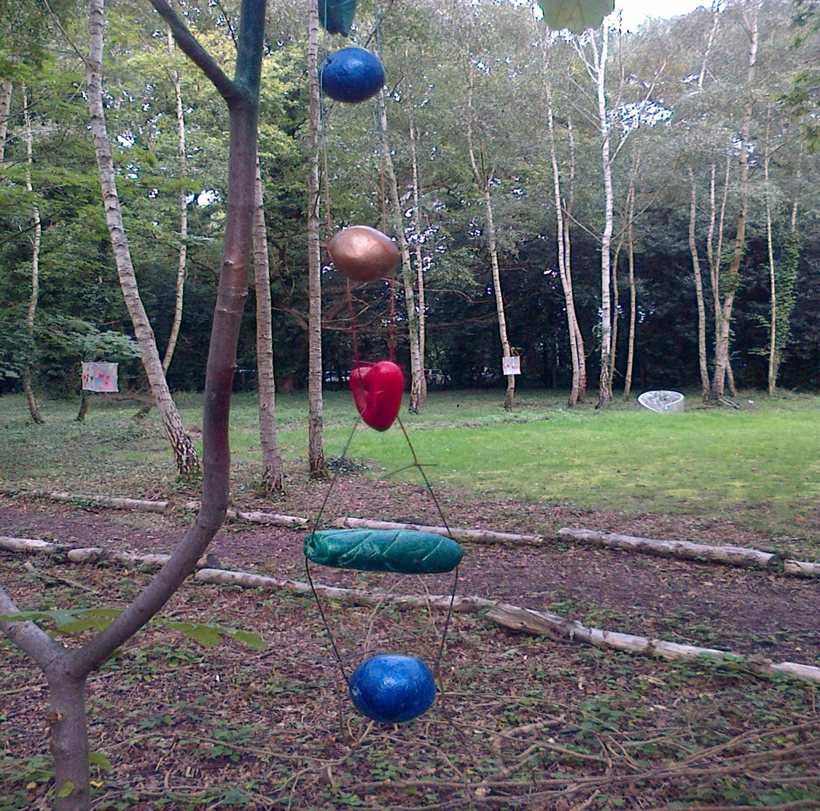

Tree Decorations created by visitors to the Burview Centre
Artist in Residence: Donagh Curwen

Contents
1. AIMS OF THE R C SHERRIFF TRUST 1
2. OBJECTIVES 2
3. PROGRAMME FOR 2014: OUTCOMES 3
3.1. Governance, Networking, Planning and Strategy: 3
3.2. General Management and Marketing: 3
3.3. Arts Projects: 4
3.4. Grants: 8
4. PROGRAMME FOR 2015: 9
4.1. Directly Managed Arts Projects: 9
4.2. Other Initiatives - To Be Achieved Through Partner Organisations 9
4.3. General Management, Marketing and Networking………………..……………… 11
5. TRUSTEES 11
6. STAFFING 12
7. ACCOMMODATION 12

APPENDICES:
- List of Grants Awarded
- Summary of Grants by Type
- Summary of Grants by Art Form
- Summary of Grants by Area

AIMS OF THE R C SHERRIFF TRUST
To develop, promote and support the amateur and professional arts in the Borough of Elmbridge, through:
- awarding grant aid to local artists, arts organisations, venues and projects
- organising and directly managing arts initiatives
- publishing and distributing a free listings magazine, “Arts Focus”, three times a year
- offering advice and information to the arts community and to members of the public.

OBJECTIVES
The R C Sherriff Trust supports the arts in Elmbridge, through its grant-making and its self-generated projects, for the following purposes:
- To support and stimulate excellence, new ideas and innovation in the arts in the borough, whether amateur or professional
- To invest in the creative talent of individual artists in Elmbridge and to provide opportunities for them to develop further their skills and knowledge
- To increase opportunities for all Elmbridge residents to take part in or experience high-quality arts activities, whatever their economic or social circumstances
- To increase resources and improve facilities for the arts in the borough
- To support and encourage initiatives aimed at the development of new audiences and venues for the arts in the borough
- To promote good practice in management, marketing, fundraising and educational work amongst arts organisations in Elmbridge, and to encourage collaboration.

PROGRAMME FOR 2014: OUTCOMES

Governance, Networking, Planning and Strategy:
- Convened 4 meetings of the full Board (quarterly)
- Continued the working relationships with Surrey Arts Officers and participated in some meetings of the Surrey Arts and Leisure Development Officers Group (SALDO)
- Met regularly with the Elmbridge Arts Development Officer to co-ordinate plans and services and to agree on areas of co-operation, such as the annual Literary Competition and the Schools’ Winter Prom
- Maintained and increased working relationships with other partners in the borough, including Brooklands Community Radio; Brooklands Museum; Carer Support Elmbridge; the Centres for the Retired; the Centre Manager at The Heart; Elmbridge Arts Council; Elmbridge Borough Council; Elmbridge Community Link; Elmbridge Museum; Elmbridge Youth Theatre; Hinchley Wood Education Trust; individual schools; JTI; Love of Learning; Music in Hospitals and the Princess Alice Hospice; Paragon Community Housing Group; Riverhouse Barn Arts Centre; Walton Business Group; Walton Charity; and Walton and Weybridge Advocacy Group.

General Management and Marketing:
- Produced and distributed 3 issues of “Arts Focus”, with a regular review of, and improvements to, the format, database, and distribution system, through the services of a freelance editor.
- Continued to improve the services and information available via the website, through the services of a freelance Webmaster.
- Continued to promote and manage the hire of our two sets of Radio Microphones (Trantec and Sennheiser systems) and small Exhibition Stands. We have 16 microphones available, various combinations of which were hired out on 9 occasions. The display boards were used by the staff to mount displays about R C Sherriff and the work of the Trust at appropriate events throughout the year.
- Continued to review and improve the office administrative systems, and to keep the Trust’s administration costs under close scrutiny.
- Administered and supervised 4 (quarterly) grant application/assessment ‘rounds’.

Arts Projects:

NB Because of the office move at the beginning of the year, and a lengthy period of sick leave for the Director, between February – June 2014, we deliberately planned a ‘quieter’ programme for 2014.

2014 Directly Managed Projects
3.3.1.1 January onwards: Elders Arts Project (a three-year programme from June 2011)

January was the start of the second ‘half’ of our third year of this project, run in partnership with Carer Support Elmbridge, Paragon Community Housing Group and Walton Charity, and supported by local business, JTI.

The weekly Singalongs started on Thursday 9th January, at Fenner and Sherwood Houses. Separate from the project, the Fenner group (which had about 30 regular members) was very honoured to be invited to sing in front of the Mayor at the Civic Centre, on Thursday 27th February, at a fundraising event for Cancer Research.

The weekly Singalong Group concluded their summer term by joining in the Strawberry Tea organised by Paragon at the Cecil Hepworth Playhouse, on Thursday 17th July, where Pete Allen and Craig Murdoch once again provided the entertainment. Our elders treated the rest of the participants to a couple of songs, taken from the programme they had performed at the Elmbridge “Leisure Live – Storm the Stage” event on Saturday 28th June, on the outdoor stage at Churchfields Recreation Ground, Weybridge (undaunted despite torrential rain…)

Because so many of our elders miss the companionship and fun of their weekly Singalongs, over the summer, this year Sam ran two informal coffee mornings: one at City Wharf House on Thursday 7th August and the other at Fenner House on Thursday 21st August, both from 10.30am – 12 noon.

The autumn term came to a triumphant conclusion with the Singalong Group’s first proper concert, when they performed as a choir on the stage of the Cecil Hepworth Playhouse, to the guests at the Paragon Christmas party, on the afternoon of Thursday 11th December at the Playhouse. One very moving feature was an excellent solo by one of our gentlemen who had never sung in public before, which was received with enthusiastic applause.

The monthly Art workshops at City Wharf House, led by the artists, Jenny Cave-Jones and Donagh Curwen, were changed to Wednesdays, from 10.30am – 2.30pm; and the members could work at a pace and on a topic which suited them, with a variety of materials to choose from.

We then went straight into our annual intensive summer art and creative writing project, again led by Jenny, at City Wharf House, Thames Ditton, from 10.30am – 2.30pm, on Tuesdays and Wednesdays 29/30th July,12/13th August, 19/20th August and 26/27th August. The focus this year was on creating two or three panels comprised of individual ceramic tiles, on the theme of “War and Peace” (as part of our commemoration of WWI) which would be displayed in the Dining Hall of JTI at a tea party for older people, on Sunday 21st September, at which our Singalong Group also provided the entertainment (under the leadership of Pete and Craig). The panels remained on exhibition for a couple of weeks, for the benefit of the JTI staff, several of whom had helped out on the arts project as volunteers, over the summer.

Over the twelve months, Sam Thompson organised 6 group outings to shows and concerts, in addition to the regular activities. This included a coach trip to the Tower of London to visit the “Blood Swept Lands and Seas of Red” art installation of ceramic poppies, commemorating the servicemen who died in the First World War, which was a very special event for our members.

These ‘extra-curricular activities’ not only provide a social life for the, often lonely, members of our Elders Arts Project, but also increase the audiences for Elmbridge arts events, so everyone benefits! The participants pay for their own tickets, but transport is provided free by either Walton Charity or Paragon, which is greatly appreciated. The project is definitely fulfilling its aim of breaking down social isolation among the elderly. Friendships have formed among the regular attendees and there is increasing cross-over between the art and the music groups.

We were extremely gratified and honoured to learn that our Elders Arts Project was the Joint Winner of the Best Healthy Living Project category, in the first “Living and Ageing Well in Surrey” Awards. Our Director attended the prizegiving ceremony at the Dorking Halls in November (with Lisa Winn, the Leisure Development Manager at EBC, who had nominated the Trust), and afterwards took the certificate and glass trophy along to show to the members of the Singalong and Art groups, who had made the success possible.

June – November: 10th Annual Literary Competition: “Dear Diary”

We had a total of 141 entries for the tenth Annual Elmbridge Literary Competition on the theme of “Dear Diary…”, which was launched in June. The closing date was Monday 27th October; judging took place on Monday 3rd November; and the prizegiving and public readings for the best entries were held at the Vera Fletcher Hall on Saturday 15th November. The afternoon session was for the 5 – 13 age-group, when the prizes were presented by a guest speaker, children’s author, Samantha Mackintosh, who gave a very amusing and inspiring talk to the young writers. Councillor Jan Fuller, the Deputy Mayor of Elmbridge, distributed the prizes to the 14 + categories at the evening session. The standard of writing and of imagination was, as ever, very high. We were delighted that, in addition to the independent entries, five schools took part in the competition this year, most of them entering pupils in more than one age category: Cardinal Newman Catholic Primary, Claygate Primary, Cranmere Primary, Heathside, and St Charles Borromeo Catholic Primary. All the winning stories and poems are now available to read on our website.

      - September – November: Schools Winter Prom

Five Elmbridge Secondary Schools participated in our ambitious Winter Prom on Friday 14th November, entitled “Remembrance of Things Past” – Claremont Fan Court School, Esher College, Hinchley Wood School and Rydens Enterprise School. Their choirs combined with members of the Promenade Youth Choir, under the direction of Christopher Goldsack, with instrumentalists from Esher College, to perform two sections from Karl Jenkins’ “The Armed Man – A Mass for Peace”, which were very powerful. The Esher College trumpeters also began and ended the evening with “Reveille” and “The Last Post” respectively. Drama students performed Shakespearean speeches (mostly for the first time on a stage, in public!) on the theme of war and peace, interspersed with musical items, from any period, interpreting the same topic. The whole event (which was a combined celebration of the 450th anniversary of Shakespeare’s birth and a commemoration of the centenary of the outbreak of WWI) was the brainchild of Pete Allen, the Arts Development Officer of Elmbridge Borough Council, who directed the show and with whom we worked in partnership. After this successful pilot, we are now planning a “bigger and better” outdoor Summer Prom, linked to Elmbridge Leisure Live, for July 2015.

Other Initiatives Financially Supported by the Trust through Partner Organisations
      - Elmbridge Hundred

After five years, this project has now drawn to a close. The Steering Group decided to use the remainder of its funds to commission writers/researchers to bring all the 100 biographies on the website up to date. This will remain a permanent research resource for the borough hosted and maintained by Elmbridge Musuem.

Photographer, Astrid McGechan, on her own initiative, and at her own cost, produced a beautiful book of local landscapes and contemporary portraits, “The Elmbridge Hundred: A Visual Journey”, to complement the project, with contributions from students from the borough’s secondary schools. This was launched on Tuesday 11th November, at the opening of her photographic exhibition of the same name, in the Robert Phillips Gallery, which was supported by a project grant from our Trust. Astrid hopes to tour the exhibition around the borough in the near future, to the same venues who hosted our 20th Anniversary “Art in the Community” photographic exhibition

      - Lantern Parades

The annual community lantern parades officially started the Christmas season: “Cobham at Christmas” on Friday 28th November, and the Walton “Festival of Light” on Saturday 29th November. The latter event was sadly overshadowed by the death of Sarah-Jane Shellard, director and co-founder of Walton Business Group, with whom we had worked closely for over ten years, having set up the first lantern processions together. She will be a great loss to the Walton Community.

      - Other Arts Projects and Organisations

The Trust continued to provide funding to other arts and community organisations to put on annual programmes of arts activities targeted at particular ‘client’ groups in the borough: Elmbridge Community Link; the Elmbridge Drama Festival; Elmbridge Youth Theatre; Esher & Dittons Youth Orchestra; Love of Learning; Music in Hospitals; Walton Charity (for the Burview Woodland Project with Elmbridge Mencap); and Wellbeing With A Goal (formerly Walton and Weybridge Advocacy Group). 2014 was also the second year of the current three-year funding agreement with Riverhouse Arts Centre in Walton (our only full-time, professional arts venue in Elmbridge). The Trust provided financial support for the Borough’s other main arts venue – the Vera Fletcher Hall in Thames Ditton – through an underwriting grant.

The Director continued as a Trustee (on a personal basis) of Hinchley Wood Education Trust.

Grants:
47 grants were awarded during the year, through a combination of Arts Initiative Projects delivered by partner organisations, Regularly Funded Organisations, Three year Funding, and the four Open Application deadlines, dispensing a total of £58,043. The “Actual” total dispensed will be less, as not all the Underwriting Grants will have been taken up in full.
A list of grants awarded is attached (Appendix I). Grants are further summarised by type (Appendix II), by art form (Appendix III), and by the ‘geographic spread’ of this expenditure, throughout the borough (Appendix IV).

PROGRAMME FOR 2015:

Directly Managed Arts Projects:
January – December: The Elders Arts Project
This project has been going from strength to strength over the past three years; so we want to continue to build on that success. We will continue the weekly Singalongs at Fenner House and Sherwood House, with Pete Allen and Craig Murdoch, and the art and writing workshops at City Wharf will be increased to twice per month, thoughout the year, because of their increasing popularity. This year there will be an emphasis on embroidery and textiles, to introduce yet another creative medium and to enable the group to participate in the Riverhouse tapestry project (see below). We are delighted that Sue Meer, the former workshop leader, has been re-recruited to join fellow artist, Jenny Cave-Jones, following the departure of Donagh Curwen.
We will continue to organise group outings to appropriate arts events in the borough.
April onwards:
The Mount Felix Tapestry, a Community Stitch Project, on the theme of the Anzac soldiers who served at Gallipoli, and the hospital set up for them in New Zealand Avenue, Walton. This will be a partnership project with Riverhouse Arts Centre (the project leaders) and EBC.
July:
Collaboration with Pete Allen, Arts Development Officer of EBC, on Proms in the Park, a young people’s event on a Friday evening, in Churchfield Recreation Ground, Weybridge, preceding Leisure Live on the Saturday, when our Elders Singalong Group will be performing as part of “Storm the Stage”. We will also be supporting EBC and Riverhouse in putting on their first Elmbridge Youth Arts Festival in
June/July – November:
The eleventh annual Elmbridge Literary Competition (in partnership with EBC), on the theme of “Flights of Fantasy”, to celebrate 150th Anniversary of the publication of “Alice’s Adventures in Wonderland”.

Other Initiatives - To Be Achieved Through Partner Organisations
Continued financial support to the Regularly Funded Organisations, arts venues, and Arts Initiative Projects grant-aided in 2014.
4.3 General Management, Marketing and Networking:
- Organising and convening 4 (quarterly) Board meetings
- Administration of 4 (quarterly) grant application deadlines/assessments
- Production of 3 editions of “Arts Focus”
- Continued improvement of the design, usefulness and accessibility of the Trust’s website
- Continued improvement of the “Recommended Artists” list, and promotion of this service to schools, youth centres and community groups
- Continued promotion and hiring out of the Radio Microphones and Exhibition Display panels
- Continued membership of the Hinchley Wood Education Trust
- Continued expansion of our network of Elmbridge and Surrey contacts/organisations.

TRUSTEES
The following served as Board Members and Trustees in the course of the year:
Cllr Barry Cheyne
Cllr Nigel Cooper (Vice-Chairman)
Cllr Mrs Elizabeth Cooper
Cllr Mrs Shweta Kapadia
Cllr Mrs Ruth Lyon
Mr Brian Nathan
Mr Frank Renton
Cllr Mrs Tannia Shipley (Chairman)
Ms Wendy Smithers
Cllr James Vickers
Co-opted members:
Mr David Walsh (Asset Management Consultant)

STAFFING

Permanent:
Loretta Howells: Director (full-time)
Sandra (Sam) Thompson: Administrator/Project Manager (full-time)
Dean Blanchard: Treasurer (part-time), assisted by Michelle Rowley, both of whom are employees of Elmbridge Borough Council (Finance Department).
Freelance:
Totum Printers printed the three issues of Arts Focus during the year.
Tim Kerr, a sound engineer, continued to maintain, and advise on, the Trust’s radio microphones, as a volunteer.
David Thompson acted as webmaster and Editor of “Arts Focus”.
David Walsh: Asset Management Consultant, retained his responsibility for overseeing the Trust’s investment portfolio and liaising with Louise Hall (Investec), the Trust’s Fund Managers.
Investec continued as the Trust’s Investment Managers. Barclays was retained as the Trust’s Bank. A Blakebrough (PIIA) undertook an Independent Examination of the Trust’s accounts, in accordance with the Charity Commission’s requirements under SORP.

ACCOMMODATION
From the end of March 2014, the Trust has been sharing premises with seven other Elmbridge charities, at 5 The Quintet, Churchfield Road, Walton, under the auspices of Walton Charity.

Loretta Howells
Director

March 2015

Elders Art Group – WW1 Tile Project
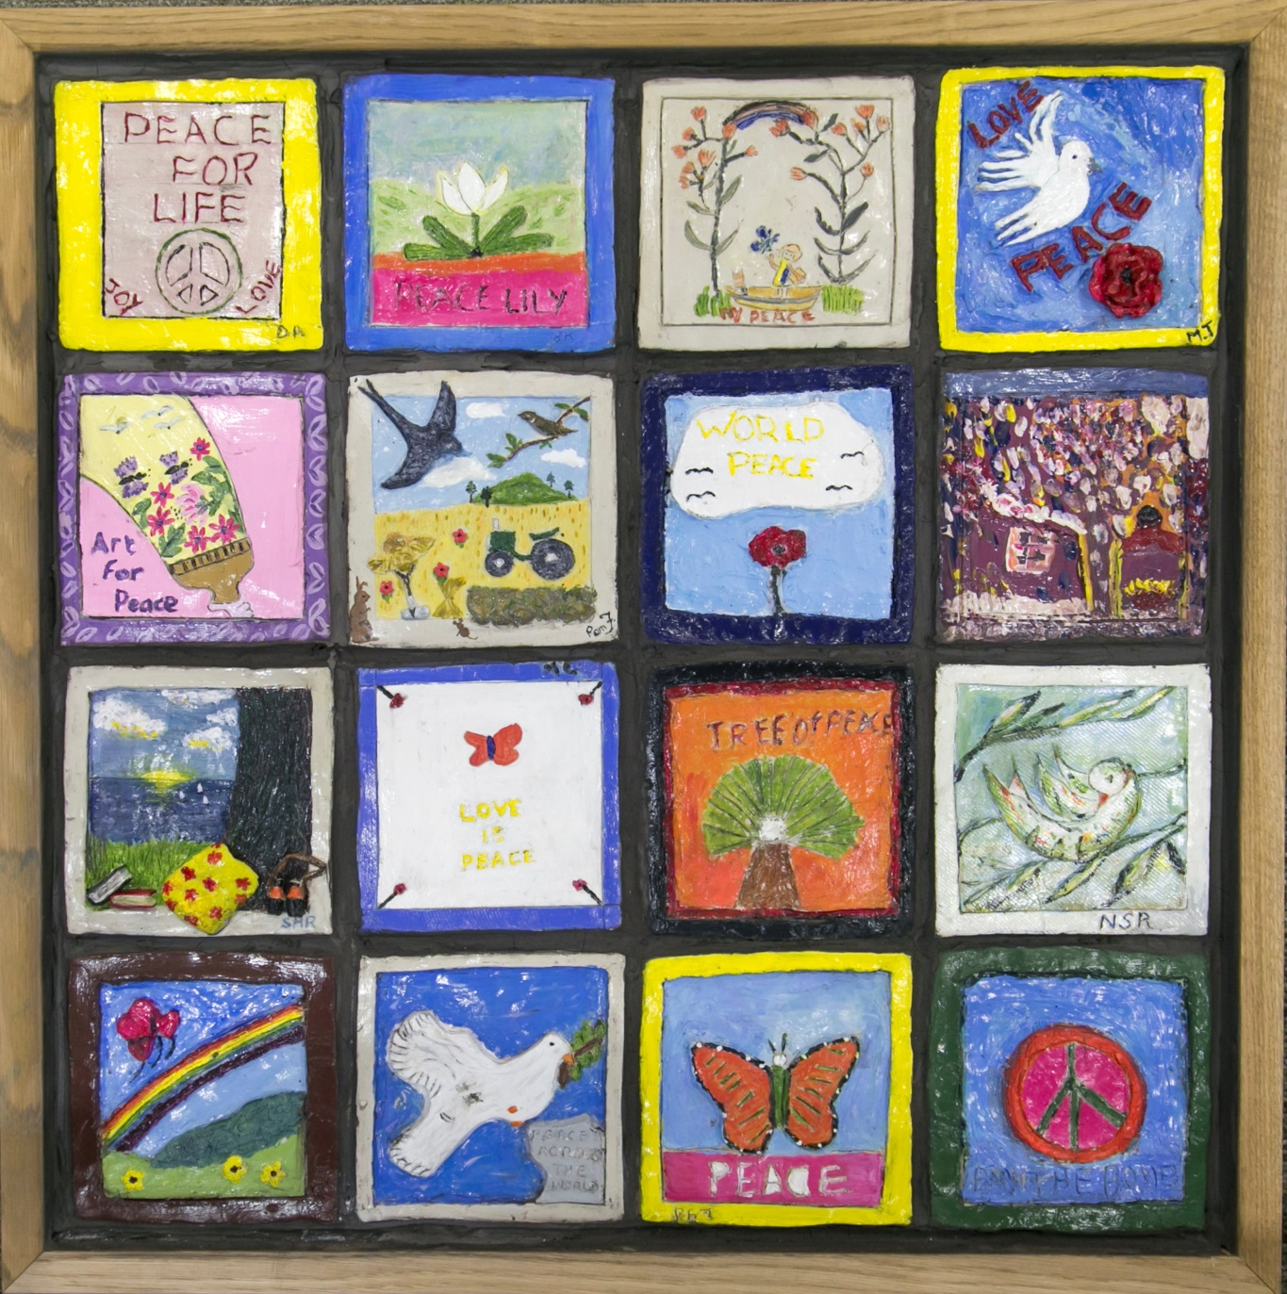
APPENDIX 1: GRANTS AWARDED 2014
GRANT NO. | NAME |  | PURPOSE |  | AWARDED
3-YEAR FUNDING
007/14 | Riverhouse Barn | A contribution to the costs of running and maintaining the Riverhouse Barn Arts Centre |  |  | £12,000.00
 | Total |  |  | 1 Grant | £12,000.00
ARTS INITIATIVE PROJECTS (AIP)

005/14 | Love of Learning | A contribution towards the costs of providing arts-based activities for disadvantaged and vulnerable groups in the Elmbridge community. |  |  | £2,500.00
006/14 | WWAG | Weekly Art Workshops, in the Riverhouse Studio, for members of the Walton and Weybridge Advocacy Group. |  |  | £3,500.00
026/14 | Esher & Dittons Youth Orchestra | Three five week courses (each culminating in a public performance) between September 2014 - May 2015 for 10-16 year olds at the Vera Fletcher Hall, Thames Ditton. |  |  | £1,500.00
027/14 | Walton Charity | A contribution to the costs of a series of Art Workshops in partnership with Burview Hall. |  |  | £1,000.00
028/14 | Surrey History Centre | Writer and filmmaker Grant Watson will work with groups of up to ten students from each of four schools, to create a short audio and film installation that explores the life of RC Sherriff, during the First World War. Using original letters and archive materials combined with creative writing from young people the intention is to recreate the trench atmosphere, in which R.C. Sherriff lived, intercut with interviews, expert testimonies, archive footage and images. |  |  | £5,000.00
 | Total |  |  | 5 Grants | £13,500.00
CAPITAL PROJECTS

015/14 | Rokoko Girls | A contribution to the cost of purchasing a PA system, microphone and stand. |  |  | £400.00
025/14 | All Saints Church, Weston Green | A contribution towards the costs of purchasing and installing a new sound system at the church, which is used for a wide range of arts events (there were 12 public concerts in 2013, and it is hoped that this number will increase with better facilities). The original system was installed twenty years ago and is now due for a major refit. It is envisaged that the project will be finished by July 2014, and training in the use of the equipment, for church members, will be provided by the installers, Hazelwood Sound, as well as by Jon Ross, an independent sound engineer who is a member of the congregation. |  |  | £1,200.00
048/14 | Oxshott Choral Society | A grant towards the cost of new staging for Oxshott Choral Society concerts in St Andrew’s Church Oxshott. |  |  | £825.00
049/14 | TWIG Singers of Hersham | A grant providing for the cost of a new piano cover |  |  | £150.00
050/14 | Walton Woodcraft Folk | A contribution to the cost of purchasing 15 ukeleles for use by group members. |  |  | £300.00
 | Total |  |  | 5 Grants | £2,875.00
PROJECT GRANTS (Individuals)

011/14 | Naomi Vidis | A grant to enable the employment of vocal coach and conductor Christopher Goldsack to work with her female singing quartet, to prepare them for a series of concerts in care homes, focusing particularly on residents suffering with dementia. |  |  | £250.00
020/14 | Hilary Boardley | A contribution towards the costs of a site-responsive art project called “Re-store”, culminating in an exhibition in the Wellington Hangar at Brooklands Museum to coincide with the Surrey Artists Open Studios fortnight (7th – 21st June). The project will focus on the Grade 2 Listed Hangar, which houses many objects, including the last surviving British Wellington bomber, prior to its planned dismantling, relocation and restoration as part of the Brooklands Aircraft Factory and Race Track Revival Project. The artists’ theme will encompass aspects of the site’s pioneering spirit through ideas of restoration, decay and the fragility of existence. A range of work will be displayed within the hangar in response to its structure and contents, remaining sensitive to a site that is to undergo major renovation and change. The group have also invited an award-winning choreographer, Katie Green, to run a one-day performance workshop for 7-11-year-olds within the context of the museum. |  |  | £500.00
035/14 | Astrid McGechan | A contribution towards the costs of mounting an exhibition for 3 weeks in the Robert Phillips Gallery at Riverhouse. Astrid will be exhibiting a selection of photographs from her new book 'The Elmbridge Hundred: A Visual Journey' (inspired by, and linked with our Elmbridge Hundred project), including the winning entries by students from Elmbridge Secondary Schools, who took part in the photographic competition earlier in the year. |  |  | £800.00
044/14 | Celia Andrews | A grant of £300, towards the costs of running a one-day drama and arts/crafts workshop, called “The Stolen Christmas”, for children, aged 7 – 11, at Riverhouse, on Monday 22nd December |  |  | £300.00
045/14 | Lottie Buchanan | A contribution towards the costs of employing a mentor to assist with re-drafting of a first novel and advising on how to establish and lead a creative writing group at school. |  |  | £60.00
046/14 | Charlotte Shipley | A grant towards the costs of participating in an exclusive masterclass with Montserrat Caballe, in Barcelona in February 2015. |  |  | £500.00
 | Total |  |  | 6 Grants | £2,410.00

PROJECT GRANTS (Organisations)

009/14 | Brooklands Museum | A contribution to the costs of the Education Department’s film-making and digital art project in the Spring term. |  | £500.00
010/14 | Monkey Theatre | A contribution to the costs of working with playwright David Rowan to create a “Murder Mystery Event” as the company’s summer production at Riverhouse, in July 2014. |  | £500.00
017/14 | Enigma Theatre | A contribution towards the costs of putting on a production of George Bernard Shaw’s “Pygmalion” at Riverhouse in October/November 2014. This will be the third production by this ambitious young company, whose aim is to bring high-quality classic drama to Elmbridge and to provide opportunities for emerging talent to gain experience in all aspects of theatre. |  | £1,500.00
019/14 | St Mary’s & St John’s Church | A grant to enable the Church to engage a caricature artist and a dance group, to entertain local residents at the annual “Big Lunch” on Sunday 1st June. It is hoped that everyone will be allowed and encouraged to take part in these artistic activities themselves. |  | £250.00
031/14 | 1st Cobham Scout Group | A contribution towards the costs of a community lantern-making project in preparation for the annual Cobham at Christmas Parade of Light. |  | £1,500.00
032/14 | Molesey Centre Social Committee | A contribution towards the costs of creating a community art garden in the grounds of the Centre, between September 2014 - April 2015. This intergenerational Vitamin G project will be led by artist, Ruth Wheeler of Sculptit whose team will run workshops for members of the community, service users, volunteers and local schools to create sculptures and other artworks. |  | £1,500.00
033/14 | Walton Business Group | A contribution to the costs of running Walton Festival of Light on Saturday 29th November 2014. The grant would be specifically to support the lead artist Imogen Andrews in her first year, and to create new large builds and smaller lanterns for the procession, working with students from local schools. |  | £1,500.00
042/14 | Friends of Claygate Day Centre | A contribution to the costs of a pilot ceramic painting workshop for retired people, with local artists from Ceramica, in November 2014. |  | £100.00
 | Total |  | 8 Grants | £7,350.00
REGULARLY FUNDED ORGANISATIONS (RFO)

001/14 | Elmbridge Arts Council | A contribution toward the costs of the Elmbridge Drama Festival, March 2014. |  | £600.00
002/14 | Elmbridge Community Link | A contribution towards their monthly music workshops and annual concert. |  | £2,500.00
003/14 | Elmbridge Youth Theatre | A contribution in the form of an underwriting grant towards EYT's major annual production in Spring 2014. |  | £1,500.00
004/14 | Music in Hospitals | A contribution towards a series of Concerts in care homes, hospitals and hospices around Elmbridge. |  | £3,000.00
 | Total |  | 4 Grants | £7,600.00
SCHOOLS FUND

008/14 | Cleves Primary School | A contribution towards the costs of a five-day residency with Strange Face Theatre Company, for 20 specially-selected pupils, during “Creative Writing Week” in March 2014, culminating in a performance for family, friends and 150 other pupils |  | £500.00
016/14 | Heathside School | A contribution to the costs of an inter-house project with artist Donagh Curwen, for 40 Year 7 students to design and create a wall mosaic representing the 4 school houses, based on the school values. The final piece will be mounted permanently in the school. |  | £500.00
029/14 | St Lawrence CofE Junior School (on behalf of a consortium) | A contribution to the cost of 3 schools participating in a mask-making and performance residency with Strangeface Theatre Company, (St Lawrence CofE Junior School, Chandlers Field Junior School and RES). |  | £1,500.00
030/14 | Walton Leigh School | A contribution to the costs of one term (Spring) of weekly attendance by 8 students at Freewheelers community Dance Group. This will widen the students’ social group as they will work with a wide range of people including older disabled dances, who will be good role models, and non-disabled dancers on joint performances. |  | £750.00
038/14 | Chandlers Field School | A contribution towards the costs of a 2-day residency, for the whole school, by storyteller, Kevin Graal. |  | £500.00
039/14 | St Albans Catholic School | A contribution towards the costs of a 2-day residency, for the whole school, by storyteller, Kevin Graal. |  | £500.00
040/14 | St Pauls RC Primary School | A contribution towards the costs of a 4-day puppetry residency, for Years 3 and 5, led by Far and Wide Puppets (director, Tony Gee), in February 2015. |  | £500.00
041/14 | Walton Oak Primary School | A contribution towards the costs of a 2-day residency, for the whole school, by storyteller, Kevin Graal. |  | £500.00
 | Total |  | 8 Grants | £5,250.00
UNDERWRITING GRANTS

012/14 | Musikidz | A contribution towards the cost of the first-ever Musikidz concert in May 2014, showcasing the talents of past and current students, aged from 7 to mid-twenties. |  | £500.00
013/14 | The Ripieno Choir | A contribution towards the cost of their spring concert of Bach Cantatas in March 2014, at All Saints Church, Weston Green. |  | £500.00
014/14 | The Vera Fletcher Hall Association | A contribution towards the cost of a series of concerts by leading musicians and a performance of Gilbert and Sullivan’s “Patience” by Charles Court Opera. |  | £1,779.00
022/14 | Oxshott Choral Society | A contribution towards the cost of their Summer Concert, featuring Faure’s “Requiem” and “Cantique de Jean Racine”, plus other pieces, at St John’s School Chapel, Leatherhead, in June 2014. |  | £429.00
023/14 | The Stringers Production Company | A contribution towards the cost of putting on a new musical “Henry, The Life and Loves of a King”. This ‘world premiere’ will take place from 18 – 28th June at the Barn Theatre, Molesey. The Stringers Production Company was formed in 2005 by 3 writer/composers. This musical will have a cast of 18 (and a professional band) and a backstage team of 18, all but 2 of whom are Elmbridge residents. |  | £1,000.00
024/14 | Walton & Weybridge Operatic Society | A contribution towards the cost of putting on their spring production of “Once Upon a Mattress”, at the Cecil Hepworth Playhouse, in May 2014. |  | £1,000.00
036/14 | Noted for Music | A contribution towards the cost of putting on a professional production of Tom Stoppard’s play 'Heroes', at the Vera Fletcher Hall. As part of the commemoration of the centenary of WW1. The play, set in a military retirement home, has a cast of three and will have a professional director. |  | £500.00
037/14 | Ember Choral Society | A contribution towards the cost of the Autumn Concert, featuring Faure's Requiem and Cantique de Jean Racine plus the Bach Magnificat and Handel's Zadok the Priest, at Holy Trinity Church, Claygate. The performance will be enhanced by the use of a professional orchestra and soloists. |  | £500.00
043/14 | Media for Good | A contribution towards the cost of staging their first live event, on Saturday 22nd November 2014, at Riverhouse |  | £500.00
047/14 | Oxshott & Cobham Music Society. | A contribution towards the cost of a concert by the Cavaleri Quartet, on 29th November 2014, at Holy Trinity Church, Claygate. |  | £350.00
 | Total | 10 Grants |  | £7,058.00
TOTAL GRANTS AWARDED |  | 47 Grants |  | £58,043.00

SUMMARY
Grants by Type 2014
 | % of Total Grants Awarded | No. of Grants | Average Grant | Total Amount Allocated
3 Year Funding | 20.7% | 1 | £12,000.00 | £12,000.00
AIP | 23.3% | 5 | £2,700.00 | £13,500.00
Capital | 5.0% | 5 | £575.00 | £2,875.00
Project Individual | 4.2% | 6 | £401.67 | £2,410.00
Project Organisation | 12.7% | 8 | £918.75 | £7,350.00
RFO | 13.1% | 4 | £1,900.00 | £7,600.00
Schools | 9.0% | 8 | £656.25 | £5,250.00
Underwriting | 12.2% | 10 | £705.80 | £7,058.00
Total: | 100.00% | 47 | £1,234.96 | £58,043.00

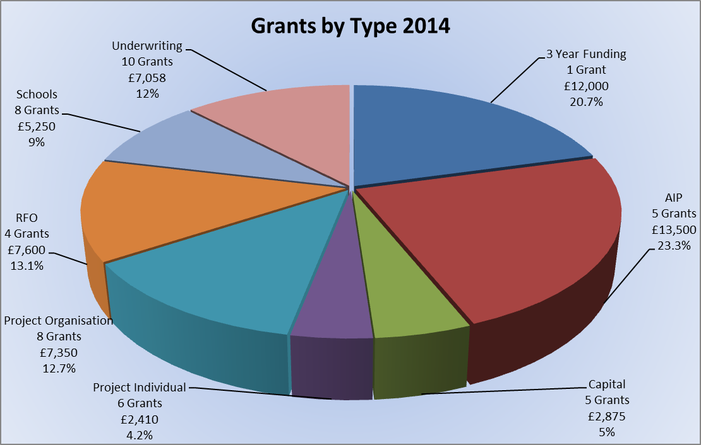

SUMMARY
Grants by Art Form 2014
 | % of Total Grants Awarded | No. of Grants | Average Grant | Total Amount Allocated
Combined Arts | 40.0% | 6 | £3,866.67 | £23,200.00
Dance | 1.3% | 1 | £750.00 | £750.00
Drama | 9.3% | 7 | £771.43 | £5,400.00
Film | 0.9% | 1 | £500.00 | £500.00
Literature | 2.7% | 4 | £390.00 | £1,560.00
Music | 25.8% | 17 | £881.35 | £14,983.00
Photography | 1.4% | 1 | £800.00 | £800.00
Visual Arts & Crafts | 18.7% | 10 | £1,085.00 | £10,850.00
Total | 100% | 47 | £1,234.96 | £58,043.00

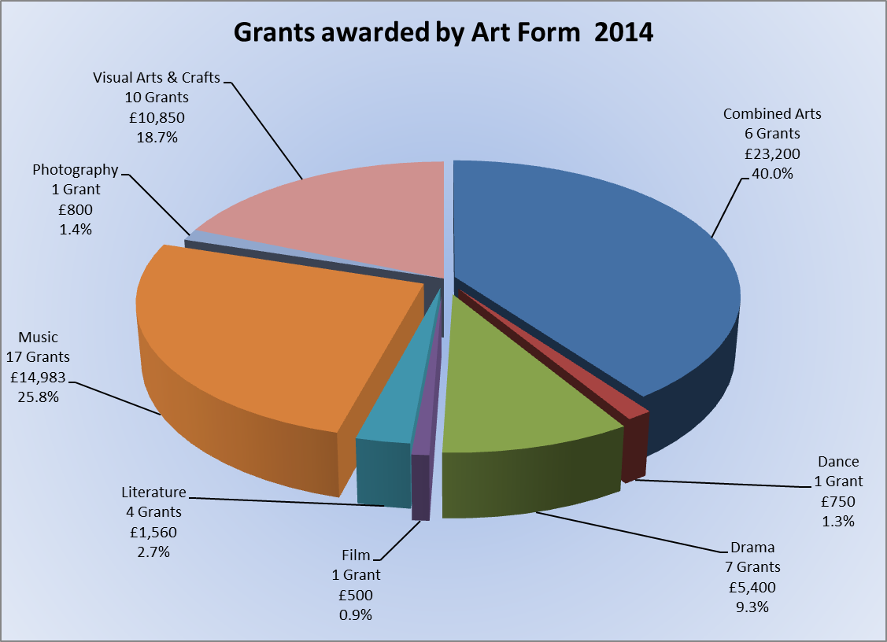

SUMMARY
Grants awarded by Area 2014
 | % of Total Grants Awarded | No. of Grants | Average Grant | Total Amount Allocated
Borough-Wide | 5.6% | 3 | £1,083.33 | £3,250.00
Claygate | 1.9% | 3 | £366.67 | £1,100.00
Cobham | 6.3% | 5 | £735.00 | £3,675.00
Esher | 2.2% | 2 | £630.00 | £1,260.00
Esher, Hersham, Hinchley Wood, Weybridge | 8.6% | 1 | £5,000.00 | £5,000.00
Hersham | 0.3% | 1 | £150.00 | £150.00
Molesey | 6.0% | 4 | £875.00 | £3,500.00
Oxshott | 0.7% | 1 | £429.00 | £429.00
Thames Ditton | 7.4% | 4 | £1,069.75 | £4,279.00
Walton | 58.4% | 20 | £1,695.00 | £33,900.00
Weybridge | 2.6% | 3 | £500.00 | £1,500.00
Total | 100% | 47 | £1,234.96 | £58,043.00

